

The Lighthouse
Zion & Trinity Lutheran Churches
950 Huron
St. Ignace, MI 49781

Address Service Requested

Nonprofit Org.
U.S. Postage
PAID
St. Ignace, MI 49781
Permit No. 55

,

The Lighthouse
Zion & Trinity Lutheran Churches
950 Huron
St. Ignace, MI 49781

Address Service Requested

Nonprofit Org.
U.S. Postage
PAID
St. Ignace, MI 49781
Permit No. 55

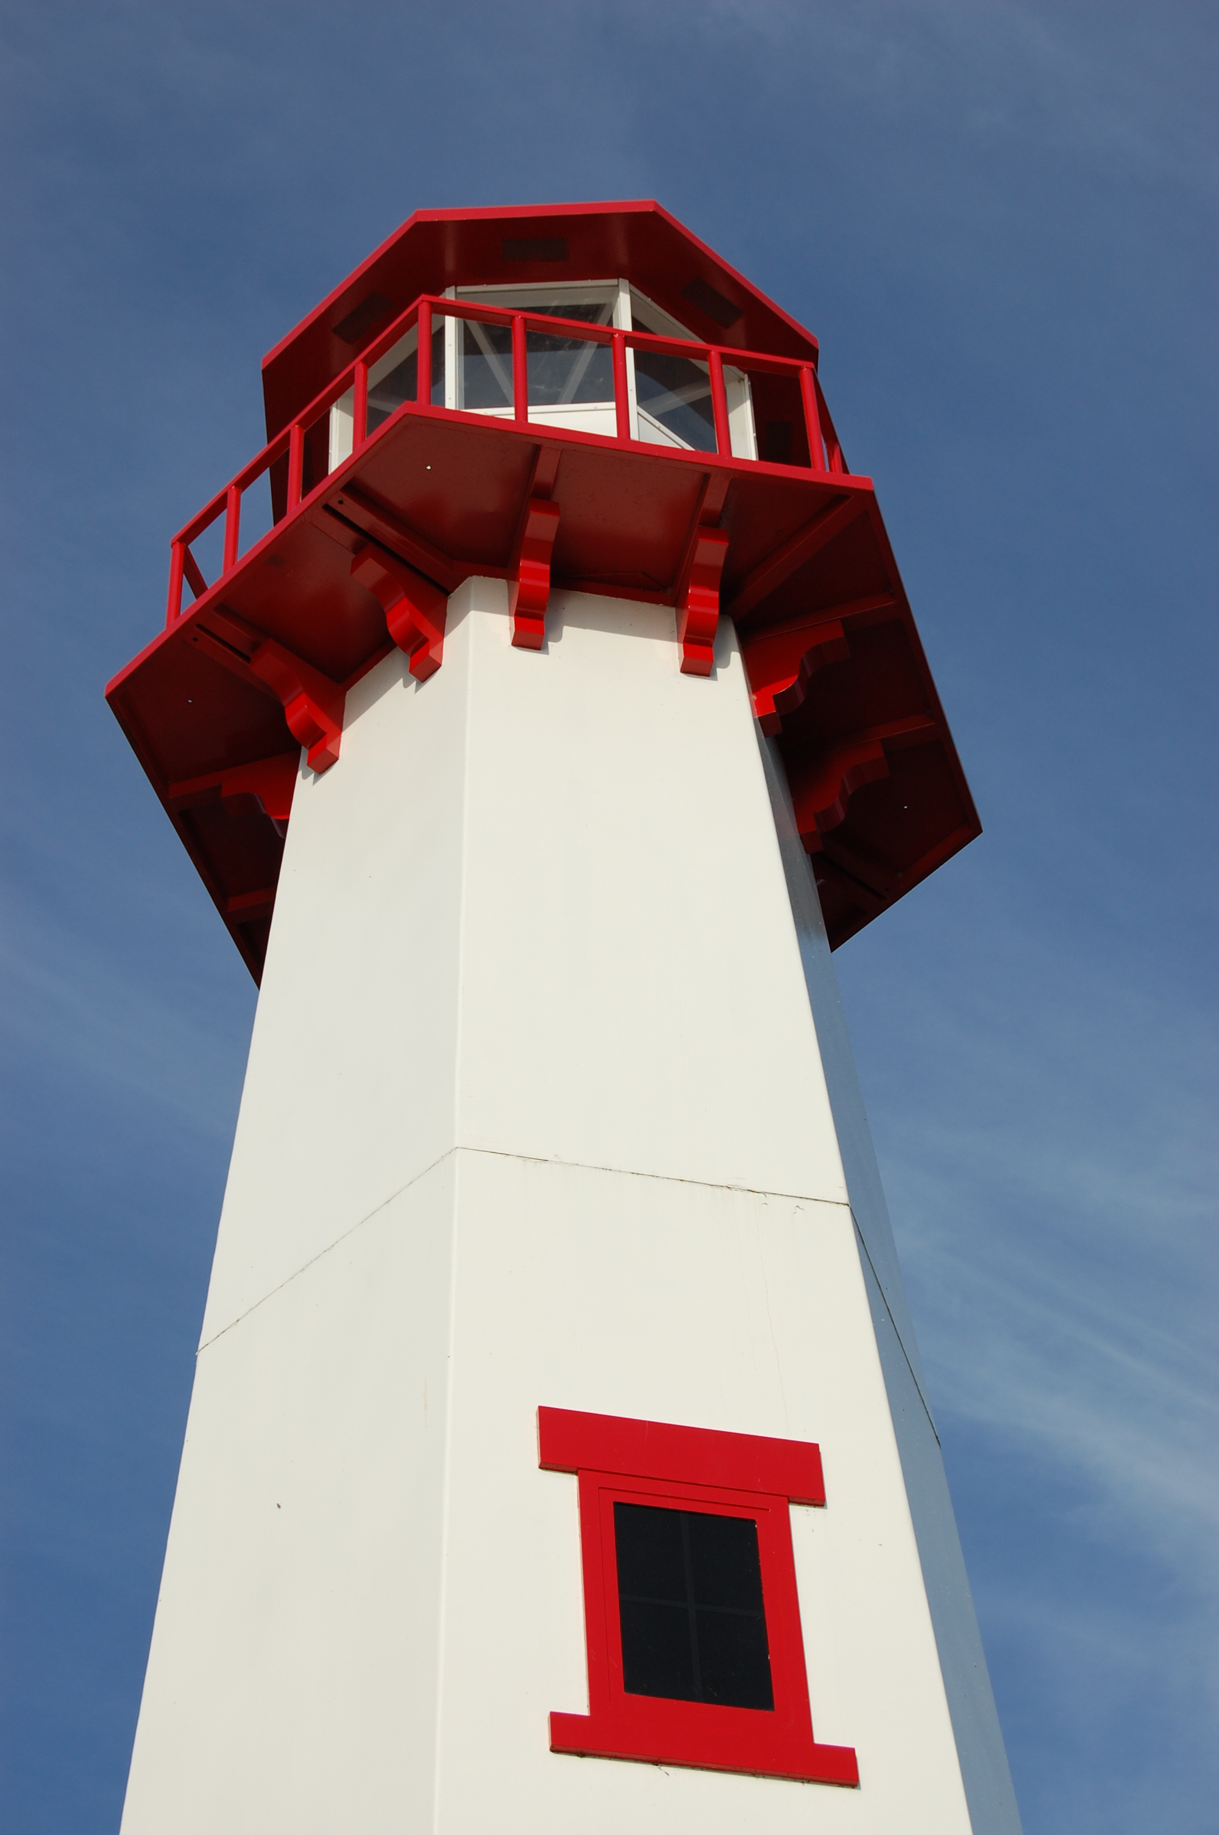
THE LIGHTHOUSE

Newsletter for September 2015

28 You, O LORD, keep my lamp burning; my God turns my darkness into light. Psalm 18:28

Message from Our Pastor

Sisters and Brothers in Christ,

It’s hard to believe we have been here a month already! It’s been a good month getting settled in and making the parsonage our new home. Of learning where everything is in the community and just plain exploring the EUP. But even better it’s been a good month as I travel around getting to know you better. I love personal stories, it’s in those stories that I learn the history of both Zion and Trinity; it’s in those stories that I hear your hopes and dreams for the future as communities of faith.

I am beginning to see all the gifts Zion and Trinity have to offer not only with each other, but also to the community around us. Both churches play an important role in the community when it comes to reaching out and caring for our neighbor who may not be a member and this is very exciting!
As I begin this journey of walking with you, and seeing all the gifts you have to share, I think of Paul in Romans 12: 4-8 when he talks about the community as the body of Christ and the gifts that make up that body we call our community of faith.
⁴For as in one body we have many members, and not all the members have the same function, ⁵so we, who are many, are one body in Christ, and individually we are members one of another. ⁶We have gifts that differ according to the grace given to us: prophecy, in proportion to faith; ⁷ministry, in ministering; the teacher, in teaching; ⁸the exhorter, in exhortation; the giver, in generosity; the leader, in diligence; the compassionate, in cheerfulness.

This month I will be passing out time and talent sheets to see what gifts you are willing share as we begin out journey together, I want to encourage you to fill them out and get them back to me, there will be many things that you may already be doing, mark them down, but there may also be things you have been wanting to try but never have, please mark them down too! If you have question I will be more than willing to sit down and talk to you about it.

As we journey together there maybe things we try that don’t work so well, that’s ok, we will try something else, it’s when we put our minds together and place our trust in God to guide us along the way that we will find the joy of living out our baptisms as children of God. I feel blessed to be called to a place that has so much to offer in the gifts you share, and I looking forward to walking with you in your ministry.

Yours in Christ,
Pastor David

Newsletter

The September Newsletter was adopted by
Pastor John R. Thompson,
who still enjoys reading it.
He invites everyone to visit Paradise Lutheran Church
of Treasure Island, Florida to worship and watch dolphins.

Pastor David

David John Tielbar
will be installed as pastor of Zion Evangelical Lutheran Church St. Ignace and Trinity Lutheran Church Brevort

on Sunday, the 20th day of September
in the year of our Lord
two thousand and fifteen
at 3 o’clock in the afternoon

at St. Zion Evangelical Lutheran Church
999 South State Street
St. Ignace Michigan

The Reverend Thomas Skrenes presiding
Bishop of Northern Great Lakes Synod
Evangelical Lutheran Church in America.

Your prayers and presence are requested.
All ordained, consecrated and commissioned
ministers are invited to process.
The Color of the day is red.

Thank You!

Thank you to everyone who helped out with Vacation Bible School. 54 children showed up and had a great time!

Noisy Offering

The noisy offering for September 6th will go to Lutheran Campus Ministries.
Blessing of the Backpacks & Teachers


Sunday, September 6th: Teachers & Children are invited for the Blessing of the Backpacks & Teachers during the service. Bring your backpacks.

Sunday Night Invite

Now that we are settled into our home we would like to invite you to an evening of fellowship, food and fun.
We have set aside each Sunday evening for members of Zion and Trinity to come and spend some time in our home. You can come as a small group or as a family. We will provide a light meal and share our stories with you and listen to yours.

Dates are filling up so give us a call at the parsonage 906-964-2051. There is also a sign up sheet near the visitor book at each church. Please call with any questions. We look forward to sharing our Sunday evenings with all of you.

Pastor Dave, Cathie and Ellie

Confirmation Meeting

Wednesday, September 30th at 7:00 pm we will be having a mandatory meeting for all confirmation students and their parents. We will discuss expectations and plans for the upcoming year of Confirmation.

Mystery

Does anyone know where the attachments to the
front sign are? They were upstairs in the closet
across from the sink.

NOIZ

We will be starting NOIZ again on October 4th. All confirmed youth are invited to come to the church as we gather together to enjoy food, games, and conversation.

Care Packages

We will be sending out “care packages” to college students and people in the military. If you would like someone added to the list, please contact Sandy Feleppa (643-6793)

Baptismal Anniversaries

Sept 1 Jake Dodds
Sept 2 Adam Therrian
Sept 3 Jeff Gamble

Sept 3 Danny Olsen
Sept 12 Taylor St. Onge
Sept 21 Sandy Feleppa
Sept 21 Eric Therrian
Sept 22 Christian Stenson
Sept 26 Bev Kammers
Sept 29 Craig Therrian

Anniversaries in September

Sept 3 Ken & Sharon Smith
Sept 11 Jerry & Susan Fenlon
Sept 16 Susan & Maurice Ekstrom
Sept 16 Sam & Darren LaVake
Sept 21 Merlin & Shannon Doran
Sept 21 Mike & Linda Wilkins
Sept 26 Craig & Jeni Therrian
Sept 28 John & Pega Kennedy

Birthdays in September

Sept 4 Jerry Fenlon
Sept 4 Mandy Bowlby
Sept 10 Zoey Stenson
Sept 12 Brad Therrian
Sept 13 Shannon Huhn
Sept 18 Susan Ekstom
Sept 19 Paul Shepard
Sept 21 Joshua Feleppa
Sept 23 Jon Olsen
Sept 28 LaRoy Hill
Sept 29 Jordan Caldwell
Sept 29 Brent Ruff

Trinity Worship Families

Sep 6 Kennedy Family
Sep 13 Movalson Family
Sep 20 Baron Family
Sep 27 Chalmers Family

Zion Funeral Committee Aug - Nov

Team Leader: Linda Wilkins (430-1465)
Co-leader: Rita LaVake (906) 298-0005

Servants for Zion

Ushers & Greeters
Sep 6 Jon & Connie Olsen
Sep 13 Confirmation Youth
Sep 20 Tim & Sally Idalski
Sep 27 Merlin & Shannon Doran

Lectors
Sep 6 Fred Feleppa
Sep 13 Judy Ryerse
Sep 20 Dawn Akers
Sep 27 Richard Galor

Communion Assistants
Sep 6 Lana Lennington
Sep 13 Paul Shepard
Sep 20 Fred Feleppa
Sep 27 Jerry Fenlon

Acolytes
Sep 6 Emma Feleppa
Sep 13 Casey Brake
Sep 20 Kennedy Kammers
Sep 27 Donovan Insley

Altar: Lorraine Graham
Money Counters: Dena Barker & Steve Christiansen

On September 13th, we will be doing the service at Long-Term Care. Please help out if you can.
Council Meetings

Zion Council – 6:30 pm, September 15th
Trinity Council Meeting – 6:00 pm, September 21st

Zion’s Council Members

President: Lana Lennington 643-6576
Vice-President Paul Shepard 984-2069
Secretary: Lorraine Graham 643-8419
Co-Treasurers: Dawn Akers 643-7552
Co-Treasurers: Lana Lennington 643-6576
Fred Feleppa 643-6793
Jerry Fenlon 643-8730
Nicole Garen 298-0490
Tim Idalski 643-6574

Trinity’s Council Members

President: Jerri Rose 292-5570
Vice-President Tracy Movalson 292-5581
Secretary: Sharon Chalmers 292-5440
Treasurer: Pega Kennedy 292-5633
Co-Treasurer: Jim Rose 292-5570
Financial Secretary: Joe Chalmers 292-5433
WELCA: Pega Kennedy 292-5633
John Kennedy 292-5633
Jim Dyer 292-5433
Lois Movalson 292-5581

Treasurer's Report for Zion
January 1, 2015 to August 15, 2015
Income:
 | Amazon Smile Foundation | 6.08
 | Building | $ 163.00
 | Church Use Income | $ 150.00
 | Thrivent Financial Income | $ 665.00
 | General | $ 29,971.00
 | Trinity Share | $ 5,249.50
 | TOTAL |  | $ 36,204.58
Expenses:
 | Administration | $ 3,814.20
 | Benevolence | $ 4,375.00
 | Church Maintenance | $ 9,471.68
 | Education | $ 565.20
 | Parsonage Maintenance | $ 737.02
 | Pastoral | $ 6,606.25
 | Worship | $ 7,217.26
 | --To Building Fund | $ 108.00
 | --To LCF Loan | $ 0.00
 |  |  | $ 32,894.61
 |  |  | 3,309.97
***********************************************************
General fund balance: |  |  | $ 910.47
Kitchen/Building Fund balance |  |  | $ 921.53
General fund owes building fund: |  |  | $ 35.00
General fund owes Mission Endowment fund: |  |  | $ 7,995.00

Zion Lutheran Council Meeting
August 18, 2015
Present: Pastor David, Dawn Akers, Fred Feleppa, Jerry Fenlon and Lorraine Graham (There were not enough members present for a quorum)

Jerry called us to order at 6:40 p.m.

Pastor David read us devotions by Dietrick Bonhoeffer.

Pastor’s Report: Pastor David presented his report.

Treasurer’s Report: Dawn presented her report.

Old Business:

Jerry gave us an update on the window installation and the new washer and dryer. The washer and windows were donated anonymously and WELCA donated the dryer. The Pastor & his wife tithed the new gutter material.

New Business:

Council members signed thank you cards for the Pulpit Supply to be presented at the picnic.

We went over the calendar for September.

We decided to have the confirmation youth participate as acolytes in September so the Pastor could become familiar them. Dawn suggested they be given training as some were new to the process.

Pastor David asked that his text studies be added to the calendar so parishioners would know he wasn’t in the office at that time. He also chose Mondays as his Sabbath from work.

We set the dates for the council meetings.

We set the date for the Confirmation Meeting.

We set a date to start NOIZ in October.

Pastor David reported that there would be a meeting on the 16th of September to discuss the 3 Lakes Lay Academy. He said that he had heard that they would not be having a fall session.

Dawn will send in a check for the Backpacks.

The Little Lutheran will no longer be published.

Lorraine reported that there was a problem with the printer. The computer and printer were not communicating. Dawn suggested talking to ATT U-verse or Williams Office Equipment. Fred said he would try to re-install the printer driver.

Lorraine reported we were also having problems with the phone system. Dawn stated she would look into getting a new set up.

Fred mentioned that the Facebook page and the Internet site were out- of-date. Dawn and Lorraine are working on them. Fred suggested that some of the high school girls might be used to keep them up-to-date.

We will put in a request for information into the newsletter regarding what might have happened to the sign attachments.

Lorraine mentioned that lifeguards from The Swim on Labor Day would be using the church on Saturday, Sunday & Monday.

We will be getting a cake for the picnic on Sunday.

The meeting adjourned at 8:30 p.m. with the Lord’s Prayer.

Respectfully submitted,
Lorraine Graham

Trinity Council Meeting
August 17th, 2015

The meeting was called to order at 6:00 p.m. with Pastor David reading a devotion from "Seize the Day."
Those present: Tracy Movalson, Lois Movalson, Jim and Jerri Rose, John and Pega Kennedy, Tom Gustafson, Sharon Chalmers and Pastor David.
PASTOR'S REPORT: There will be a picnic potluck August 23, at Zion after church to welcome the Tielbar family and to thank the Pastors who served our churches before Pastor David arrived.
The Installation of Pastor David will take place Sunday at 3:00 on September 20th followed by a potluck.
SECRETARY'S REPORT: Read and Approved
TREASURER'S REPORT: Read and Approved
FINANCIAL SECRETARY'S REPORT: Read and Approved
OLD BUSINESS
1. Jerri talked to Allen Staige about our stain glass windows. He estimates the repairs will cost approximately $1,800.
2. Kathleen Dickmann talked to a restorer about cleaning our painting.
NEW BUSINESS
1. School backpacks - we agreed to supply 3 backpacks
2. Non-profit license - Pega will assist Jerri on filling out the paperwork to get the license. It is due 10/1/15.
3. Pastor David will look into helping us get our archives and history into digital form.
The meeting was adjourned at 7:00 p.m. with the Lord's Prayer
Respectfully submitted,
Sharon Chalmers, secretary

Spartan Labels

We are now collecting Spartan Labels to raise money for Zion. Collect the UPC labels from any Spartan product and bring them to the church. We have 200, we need to reach 1000.


Prayer List

(If you would like someone added to the prayer list, call the church at 906-643-7870)


Jim Dyer, Carl & Mary Belonga, LaTaunya Paquin, Phil Richel, Barb Lehto, Charlie Lamoreaux, Beth Ann Amacher, Joel Morabito, Joanne Truman, Greg Mitchinson, Kelli Morrison, Ric Mulholland, Jim Rose, Troy Johnston, Dave Movalson, Pega Kennedy, Jim Ryerse, Steve Ingalls, Tom Coffey, Jane Yoder, Lance Litzner, Jim Scott, Ernie Langstaff, J.C. Kelly, Lewis Thompson, and Karla Wildberger, Kathy Perry, Sara Soblasky, Pam Kaminsky, Lori Bowlby and the families of Becky Barber, Ruth Visnaw and Barb LaJoice

Labor Day Events

Arts Dockside: Over 100 exhibits of original and unique arts and crafts along the beautiful waterfront at the St. Ignace Public Marina. Music, food, and fun add to the festivities!
Show Hours:
Saturday, September 5 - 9:00 a.m. - 6:00 p.m.
Sunday, September 6 - 9:00 a.m. - 5:00 p.m.

58th Annual Bridge Walk: You may start walking anytime after the Governor's party starts the walk at approximately 7:00 a.m. NO ONE WILL BE PERMITTED TO START AFTER 11:00 a.m., so arrive early. There is NO FEE or registration to participate in the walk. Bus transportation from Mackinaw City to St. Ignace is available at $5 per person (infants are free).

Pastor David Tielbar may be reached at 906-984-2051 or at david.tielbar6@gmail.com. In an emergency, you can reach the Pastor’s cell phone at (563) 880-4512

Church telephone: 906-643-7870 - Answering machine
The secretary will usually be in the office on Tuesday and Thursday mornings from 9 - 12

To email the church is: ziontrinity950@yahoo.com
The website is at http://zionstignace.com/home.html
- Find us on facebook at www.facebook.com/zionstignace

Zion Evangelical Lutheran Church and Trinity Lutheran Church are congregations of the Northern Great Lakes Synod and the Evangelical Lutheran Church in America.

Trinity Lutheran Church
W4528 Fishermans Drive
Moran, MI 49760
Worship Service: Sundays at 9 a.m.

Zion Evangelical Lutheran Church
999 S. State Street
St. Ignace, MI 49781
Worship Service: Sundays at 11 a.m.

